Difference between white box, black box, and gray box testing

**Black box** testing is a testing strategy based solely on requirements and specifications. Black box testing requires no knowledge of internal paths, structures, or implementation of the software being tested.  
  
**White box** testing is a testing strategy based on internal paths, code structures, and implementation of the software being tested. White box testing generally requires detailed programming skills.  
  
There is one more type of testing called **gray box** testing. In this we look into the "box" being tested just long enough to understand how it has been implemented. Then we close up the box and use our knowledge to choose more effective black box tests.  
  
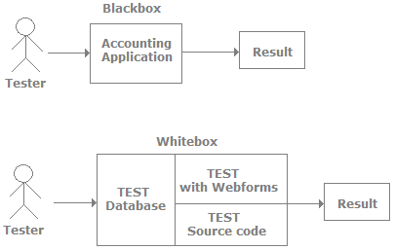  
  
The above figure shows how both types of testers view an accounting application during testing. Black box testers view the basic accounting application. While during white box testing the tester knows the internal structure of the application. In most scenarios white box testing is done by developers as they know the internals of the application. In black box testing we check the overall functionality of the application while in white box testing we do code reviews, view the architecture, remove bad code practices, and do component level testing.

Usability testing

Usability testing is a testing methodology where the end customer is asked to use the software to see if the product is easy to use, to see the customer's perception and task time. The best way to finalize the customer point of view for usability is by using prototype or mock-up software during the initial stages. By giving the customer the prototype before the development start-up we confirm that we are not missing anything from the user point of view.  
  
Software Testing Image

Performed all the above test by creating test cases and the result was observed as below**:**

Report: The case is marked as 'Pass' for steps 1 – 10. Hence the functionality can be implemented.